**Sri Sivasubramaniya Nadar College of Engineering**

**Data analytics**

**Assignment 1**

**The case of 50 Start Ups**

**Name:** Sidharth B

**Roll No:** SSNCE195002114

**Branch:** Information Technology

1. **Heat Map:**

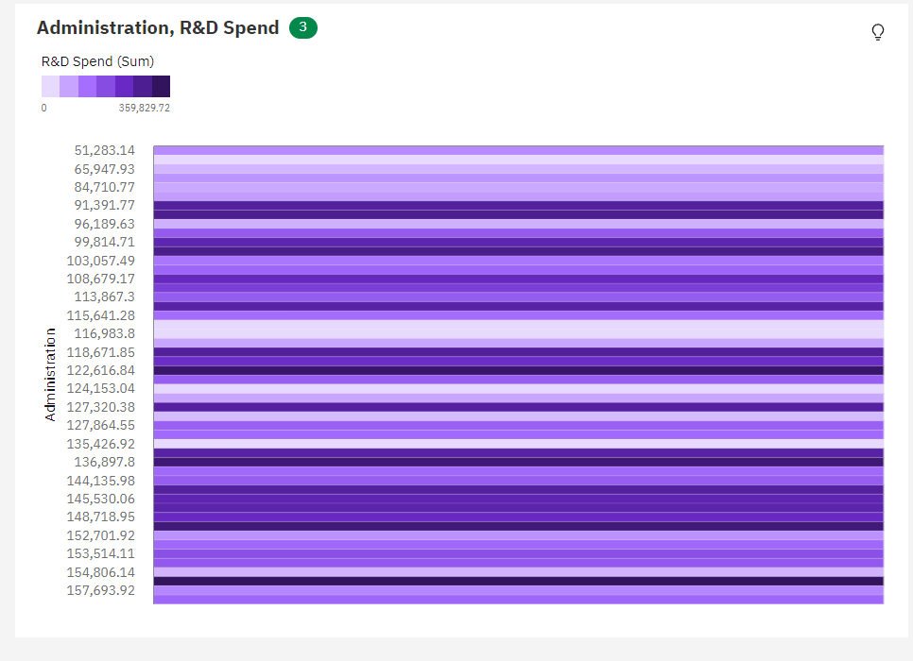

1. **Pie Chart:**

1. **Box plot:**

1. **Network:**

1. **Crosstab:**

1. **Spiral:**

